

***Metric conversion***

**E-Project Documentation**

**Teacher Name: Miss: Syeda Imama**

**APTECH COMPUTER EDUCATION**

**HYDERABAD-1 PAKISTAN**

**Issue Date: 29-june-2023**

TABLE OF CONTENT

|  |  |  |
| --- | --- | --- |
| **S No** | **Contents** | **Page No** |
| 01 | Certificate | 3 |
| 02 | Acknowledgement | 4 |
| 03 | Project Report | 5 |
| 04 | Problem Definition | 6 |
| 05 | Customer Requirements Specification  (CRS) | 7 |
| 06 | Architecture Design of the Project | 11 |
| 07 | System Requirement | 11 |
| 08 | Task Sheet | 12 |
| 09 | Project Plan | 13 |
| 10 | Checklist of work Progress | 14 |
|  |  |  |
| 11 | Screen Shots | 15 |
| 12 | Source Code | 19 |

CERTIFICATE

This is to certify that

***• M: BAKHSH • SHARIQ HUSSAIN***

***• USMAN KHAN • SHAZAIB BHATTI***

Has successfully Designed

**Metric conversion**

Submitted by:

***• M: BAKHSH • SHARIQ HUSSAIN***

***• USMAN KHAN • SHAZAIB BHATTI***

Date of Issue: 29-JUNE-2023

**Authorized Signature:** **Miss: Syeda Imama**

ACKNOWLEDGEMENT

First and foremost, we would like to express our deep gratitude and most heartfelt thanks to almighty ALLAH for his blessings, for lightening up our heart with the torch of knowledge and for giving us the ability to complete this project.

We would like to thanks Aptech Worldwide and the team of E-Project for their generous support and clarifying the doubts regarding e-project. We would like to acknowledge the way of explanation which the team of e-project gave in e-project to make website and we are equally grateful to our teacher (Miss: Syeda Imama Ali) for giving us a moral support and guiding us different matters regarding project in all the time about the research and writing of this project.

We are greatly indebted to Aptech Worldwide, Sir Amjad Ali, Faculty Members and ACE Hyderabad, Pakistan for encouragement and incessant help.

PROJECT REPORT

**BY:**

**MUHAMMAD SAQUIB**

**Project Title: METRIC conversion,**

**Members Name: M: bakhsh, Shariq Hussain**

**Usman Khan Shazaib Bhatti**

**Batch Code: 2302F**

**Start Date: 29- june-2023**

**End Date: 21-july-2023**

**Course: ACCP (CPISM)**

**Teacher: Miss: Imama Syeda Ali**

**Center Manager: Sir Shoaib Ahmed**

**Center Academic Head: Sir Zubair**

**Center Name: ACE Hyderabad-1, Pakistan**

Submitted as

E Project Documentation

**PROBLEM DEFINITION**

Why does one need metric conversion for? Science projects seem more authoritative when the units used are metric units, such as grams, milliliters, and degrees Celsius.

Anyone can do good backyard science with inches and ounces, but when he shows his work in a science fair, metric conversion will show that he understands the importance of these units to scientists.

**Customer Requirement Specification**

There are various units of measurement; one of the earliest types of measurement concerned that of length. Many times, we need to convert some data from one unit to other. Hence you are expected to develop a calculator for such metric conversions.

Customer expectations:

You need to develop the metric converter which will satisfy the following requirements.

There should be a separate web page that displays the metric conversion chart. The chart should include the multiplying factors for the conversion

Length conversion:

Should include the multiplying factors for following

Inches millimeters

Feet Meters

Yards - Meters

Miles Kilometers

Area conversion

Should include the multiplying factors for following

Square inches Square millimeters

Square feet Square meters

Square yards Square meters

Acres Hectares

Square miles Square kilometers

Volume conversion

Should include the multiplying factors for following

fluid ounces milliliters

gallons liters

cubic feet - cubic meters

cubic yards - cubic meters

Mass conversion

Should include the multiplying factors for following

Ounces grams

Pounds kilograms

short tons (2000 lb.) - mega grams (or "metric ton")

Temperature conversion

Fahrenheit Celsius

Celsius Fahrenheit

There should be separate web pages for the various conversions, you need to include the conversions of

Area

Length

Volume

Mass

Temperature

Currency

Along with the above conversion techniques, there should also be information related to all the measurement units as how / who invented them. A brief history about these units should be provided under the separate section as history of measurement units

Provide some articles e.g.

The SI System: An article describing what the SI system of units is

Metric System: An article describing the differences between the various metric systems.

The meter an article defining the meter as used in the metric system, both past and present.

Traditional U.S. Units: An article describing the traditional units of measurement used throughout the United States.

You can include any related articles to the topic.

Also provide the frequently asked questions (FAQs) like

How do I enter numbers in Scientific Notation?

What is a knot? What is a nautical mile?

What about rainfall? How do I convert between inches of rain, and millimeters of rain?

What is the difference between the long ton, short ton, and metric ton?

At what temperature are Celsius and Fahrenheit the same?

PROJECT OBJECTIVE:

The Objective of this program is to give a sample project to work on real life

projects. These applications help you build a larger more robust application.

The objective is not to teach you JavaScript/Dreamweaver but to provide you with a

real life scenario and help you create basic applications using the tools.

You can revise the chapters before you start with the project.

This project is meant for students who have completed the module of

Dreamweaver. These programs should be done in the Lab sessions with assistance

of the faculty if required.

It is very essential that a student has a clear understanding of the subject. Students

should go through the project and solve the assignments as per requirements given.

Kindly get back to E-projects Team in case of any doubts regarding the application or

its objectives.

Architecture & Design of the Project:

Since the website will have client server architecture it will have one-tier architecture.

System Requirement:

|  |  |  |
| --- | --- | --- |
| **SR.No** | **Items** | **Description** |
| 01 | Operating System | Window 10, Win7 or win8 |
| 02 | Main Processor | Minimum 2ghz or better |
| 03 | Ram (Memory) | Minimum 512mb or better |
| 04 | Web Browser | Google Chrome or Firefox (Latest) |
| 05 | Software | Notepad, HTML editor, Cofeecup, JS, Bootstrap Dreamweaver |

TASK SHEET

|  |  |  |  |  |  |
| --- | --- | --- | --- | --- | --- |
| **Project Ref. No:** | | **Date of Preparation of Activity Plan:** | | | |
| SR.  No | Task | Actual  Start  Date: | Actual  Day: | Team  Mates  Names: | Status: |
| 01 | Planning | 29-June-2023 | 1 | ▪M: BAKHSH,  ▪SHARIQ HUSSAIN,  ▪USMAN KHAN, ▪SHAZAIB BHATTI | YES |
| 02 | Data  Collection | 29-June-2023 | 1 | ▪M: BAKHSH,  ▪SHARIQ HUSSAIN | YES |
| 03 | Designing  Home  Page | 01-July-2023 | 4 | ▪M: BAKHSH,  ▪SHARIQ HUSSAIN | YES |
| 04 | Linking | 10-July2023 | 9 | ▪M: BAKHSH | YES |
| 05 | Check  Links | 12-July-2023 | 2 | ▪M: BAKHSH | YES |
| 06 | Finalizing | 15-July-2023 | 3 | ▪M: BAKHSH,  ▪SHARIQ HUSSAIN | YES |
| 07 | Testing | 17-July-2023 | 2 | ▪M: BAKHSH,  ▪SHARIQ HUSSAIN,  ▪USMAN KHAN, ▪SHAZAIB BHATTI | YES |
| 08 | Documentation | 18-July-2023 | 1 | ▪SHARIQ HUSSAIN | YES |
| 09 | Uploading | 21-July-2023 | 2 | ▪M: BAKHSH,  ▪SHARIQ HUSSAIN | YES |

PROJECT PLAN

* Website is able to execute quickly.
* The color scheme of the site looks attractive.
* The collection of data is authentic and taken by the most popular product websites.
* There is authentic information of facilities products with their specifications.
* Background is different to main page.
* The HOME is well prepared exactly for the same page as user clicks on the link.
* A visitor can also view the individual image of our every gallery.

CHECK LIST OF WORK PROGRESS

|  |  |  |
| --- | --- | --- |
| **SR.No** | **Aspect Tested** | **Remarks** |
| 01 | Data Collection | **yes** |
| 02 | Designing Home Page | **yes** |
| 05 | Linking The Pages | **yes** |
| 06 | Finalization | **Yes** |
| 08 | Tasting The Site | **Yes** |
| 09 | Documentation | **yes** |

SCREEN SHOTS

Home-page-1

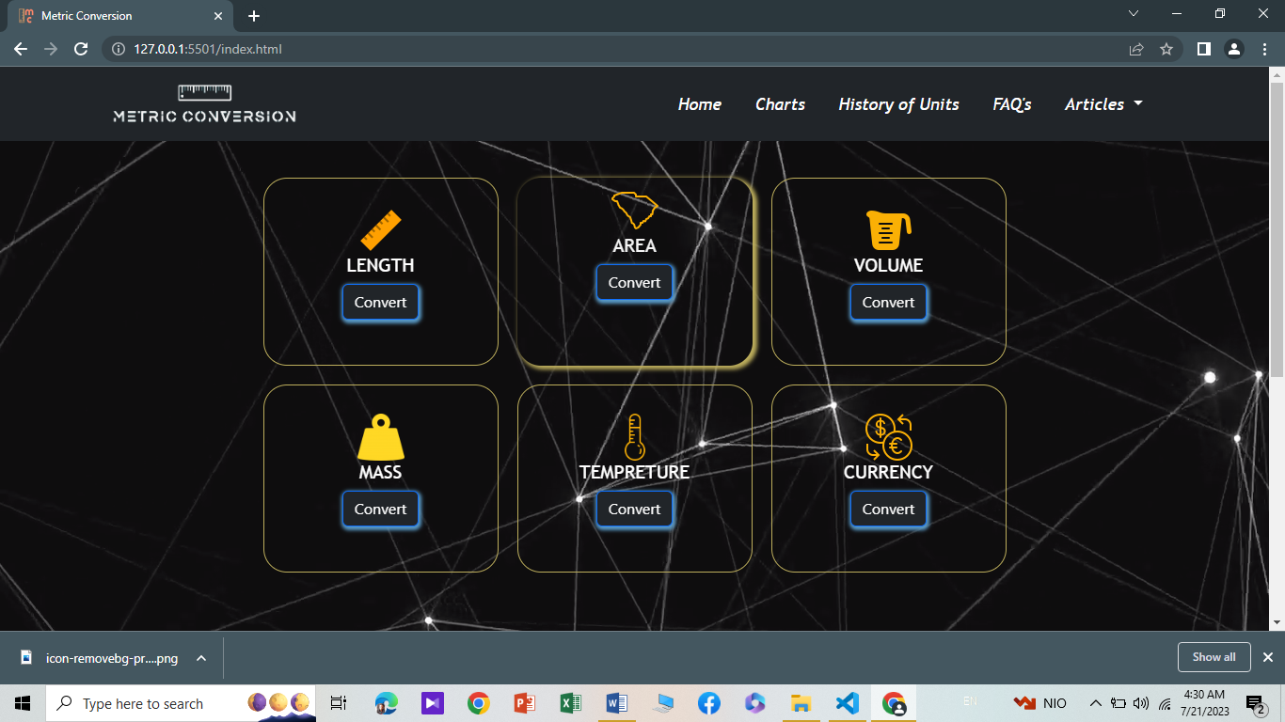

Home-page-2

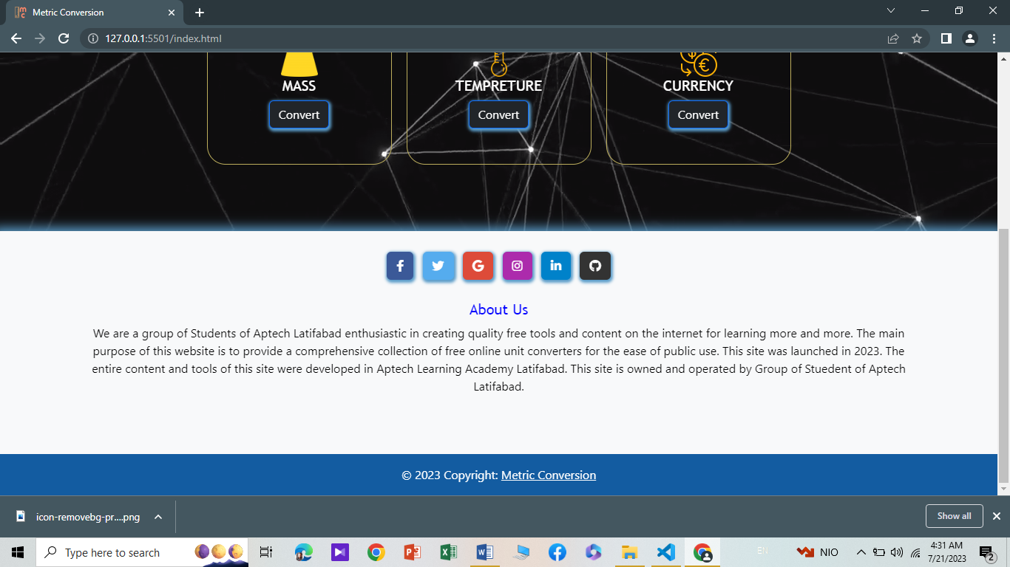

Converter-page

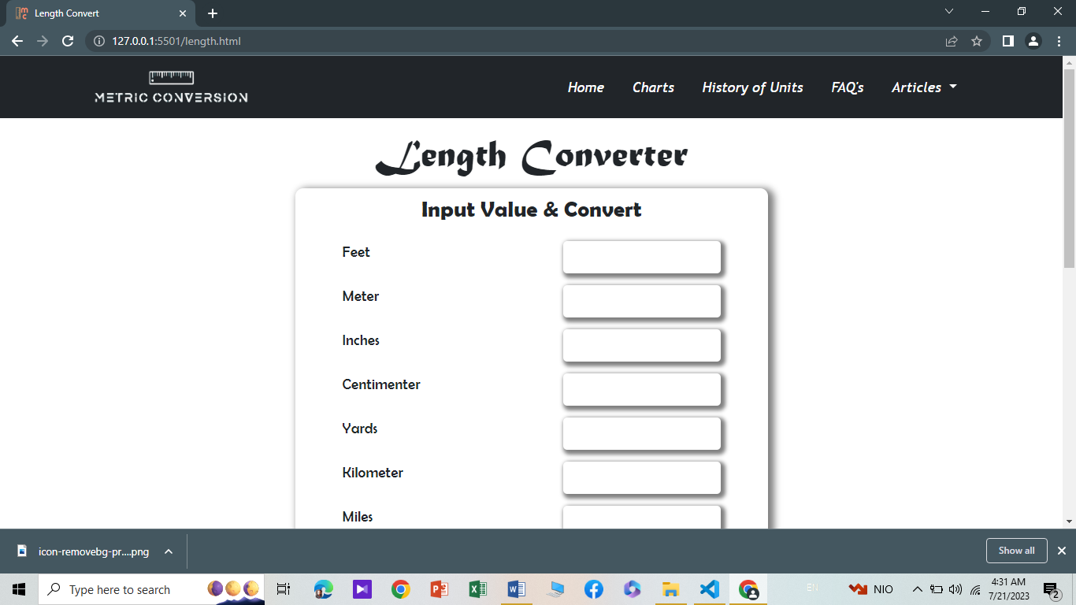

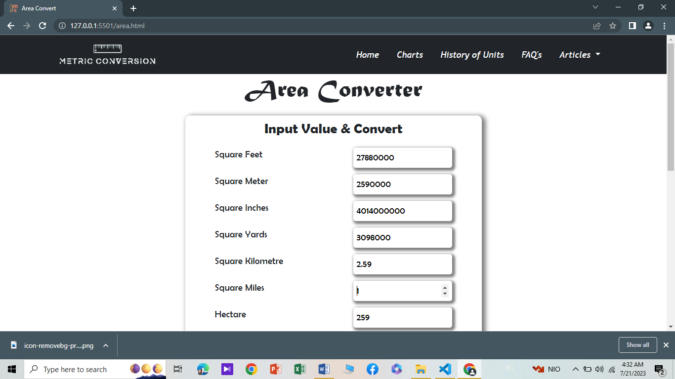

HISTORY-PAGE

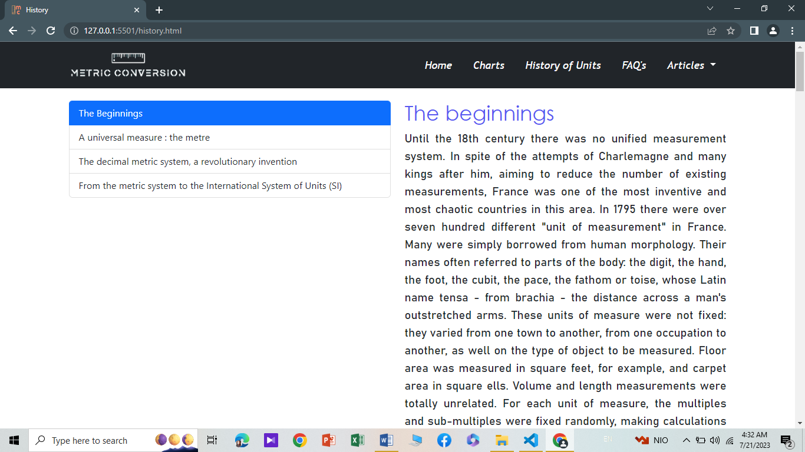

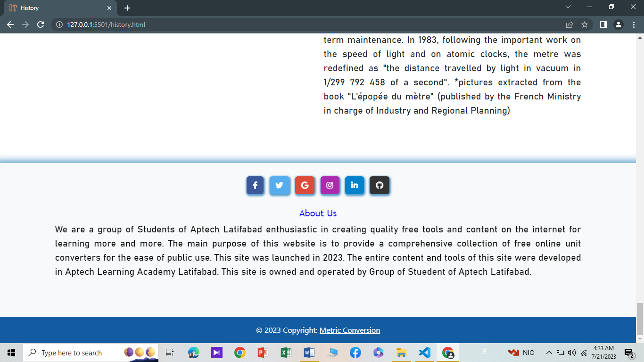

FAQ’S-PAGE

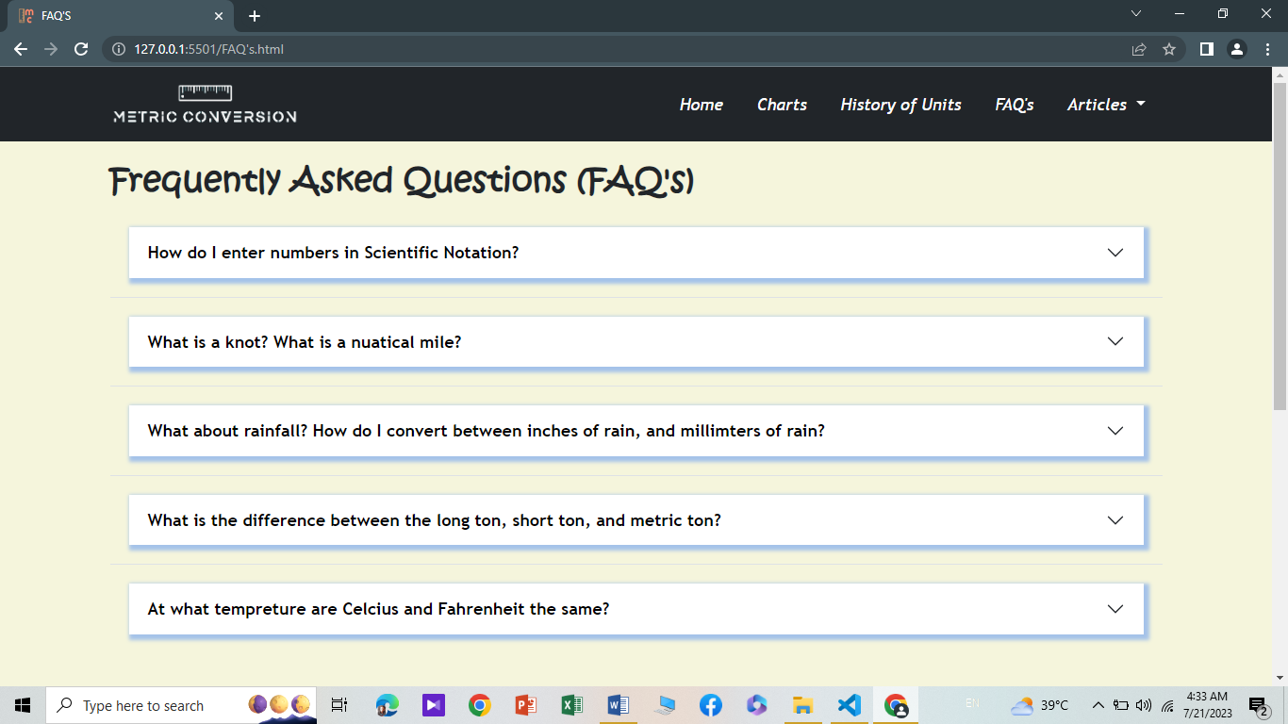

ARTICLE’S-PAGE

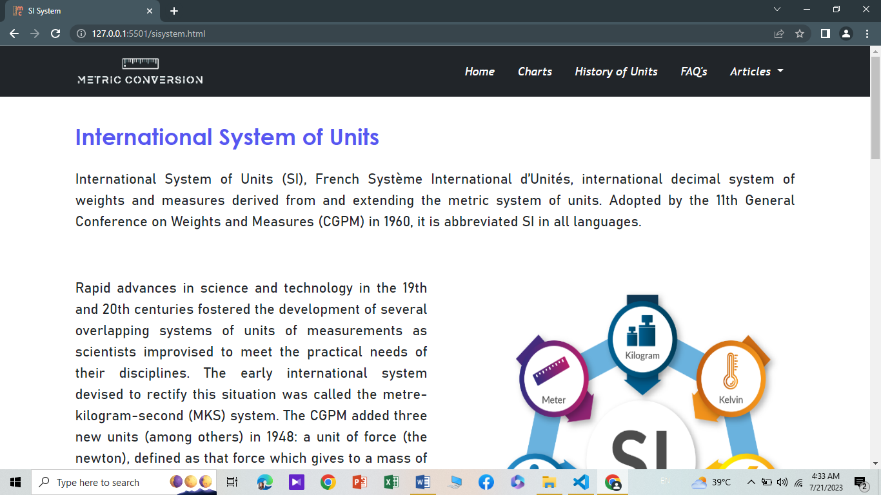

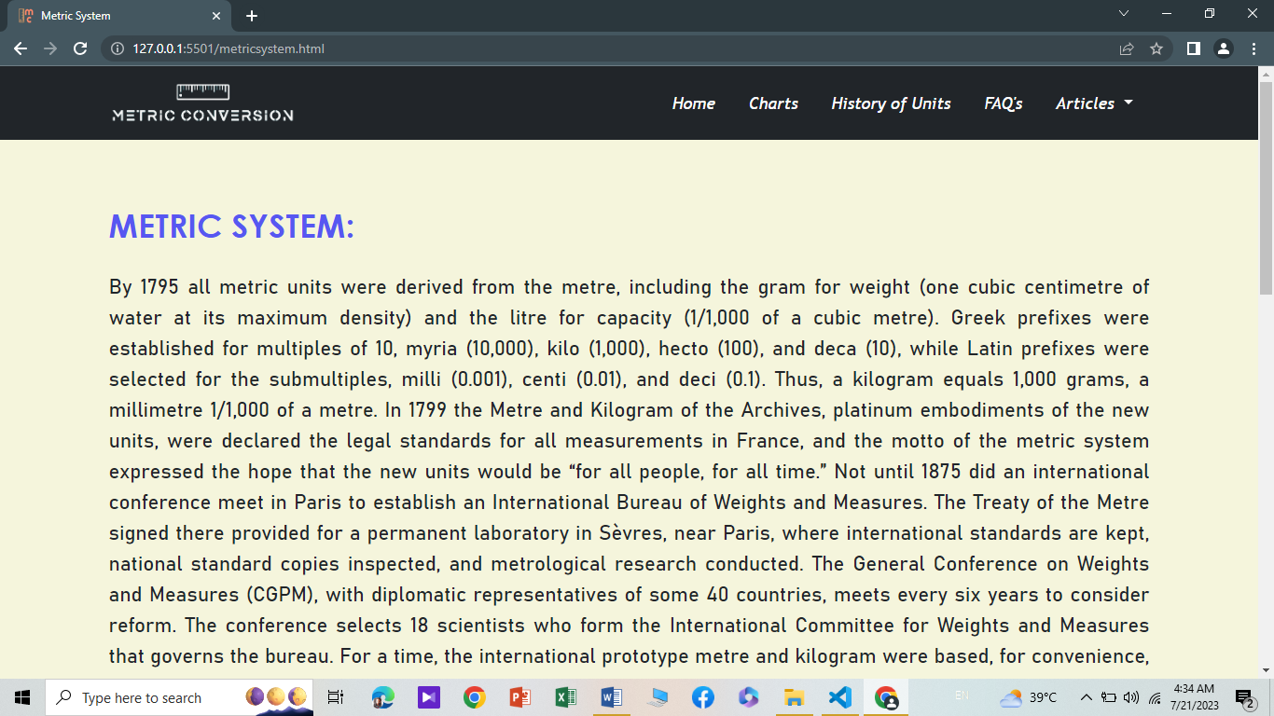

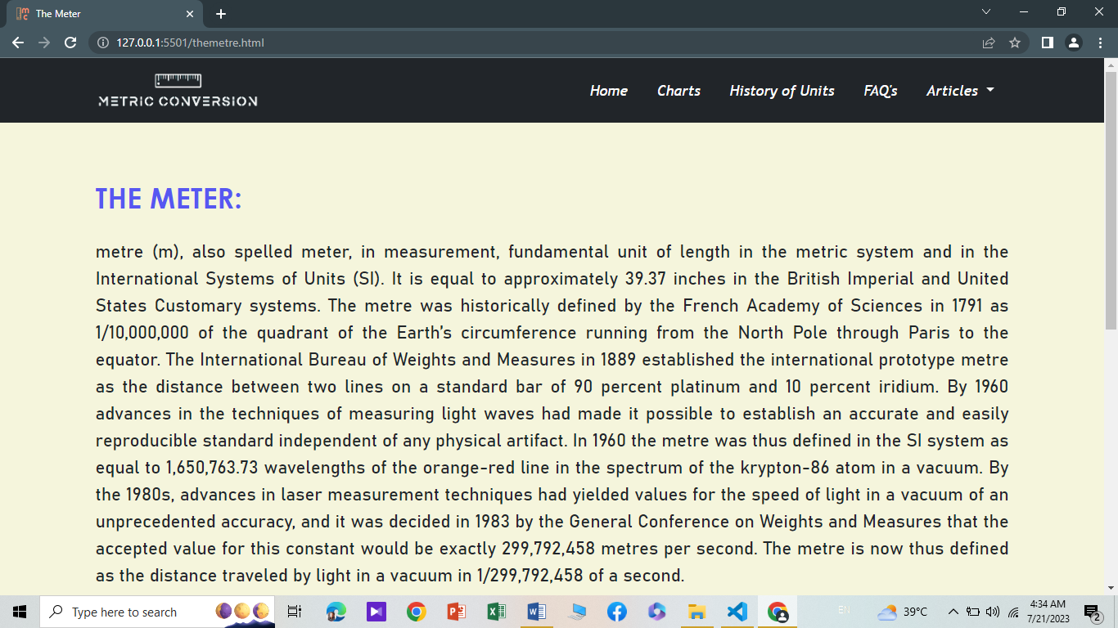

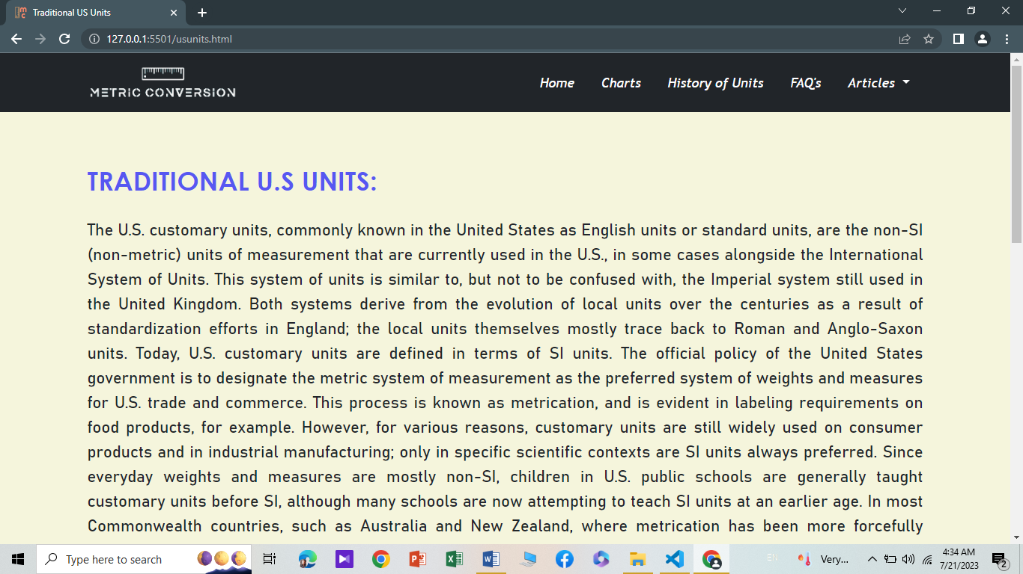

SOURCE-CODE

<!DOCTYPE html>

<html lang="en">

  <head>

    <meta charset="UTF-8" />

    <meta name="viewport" content="width=device-width, initial-scale=1.0">

    <title>Metric Conversion</title>

    <link rel="icon" href="images/icon-removebg-preview.png" type="icon">

    <link rel="stylesheet" href="bootstrap-5.2.3-dist/css/bootstrap.min.css">

   <link rel="stylesheet" href="fontawesome-free-5.15.4-web/css/all.min.css">

   <link href="https://unpkg.com/aos@2.3.1/dist/aos.css" rel="stylesheet">

   <script src="https://unpkg.com/aos@2.3.1/dist/aos.js"></script>

   <link rel="stylesheet" href="css/firstpage.css">

  </head>

  <body>

  <!-- backgound -->

    <video autoplay muted loop id="myVideo" >

      <source src="video/black.mp4" type="video/mp4"  />

      </video>

<!-- Navbarstart -->

<nav class="navbar navbar-expand-lg navbar-light bg-dark static-top" style="top: 0px ; position: absolute;">

  <div class="container">

    <a class="navbar-brand" href="#">

    <img src="images/logo-removebg-preview.png" alt="..." height="36">

    </a>

    <button class="navbar-toggler" type="button" data-bs-toggle="collapse" data-bs-target="#navbarSupportedContent" aria-controls="navbarSupportedContent" aria-expanded="false" aria-label="Toggle navigation">

    <span class="navbar-toggler-icon"></span>

    </button>

    <div class="collapse navbar-collapse" id="navbarSupportedContent">

    <ul class="navbar-nav ms-auto">

      <li class="nav-item">

      <a class="nav-link" aria-current="page" href="index.html">Home</a>

      </li>

      <li class="nav-item">

      <a class="nav-link" href="charts.html">Charts</a>

      </li>

      <li class="nav-item">

        <a class="nav-link" href="history.html">History of Units</a>

        </li>

        <li class="nav-item">

          <a class="nav-link" href="FAQ's.html">FAQ's</a>

          </li>

        <li class="nav-item dropdown">

          <a class="nav-link dropdown-toggle" href="#" id="navbarDarkDropdownMenuLink" role="button" data-bs-toggle="dropdown" aria-expanded="false">

            Articles

          </a>

          <ul class="dropdown-menu dropdown-menu-dark" aria-labelledby="navbarDarkDropdownMenuLink">

            <li><a class="dropdown-item" href="sisystem.html">SI system</a></li>

            <li><a class="dropdown-item" href="metricsystem.html">Metric system</a></li>

            <li><a class="dropdown-item" href="themetre.html">The Metre</a></li>

            <li><a class="dropdown-item" href="usunits.html">Traditional U.S Units</a></li>

          </ul>

        </li>

    </ul>

    </div>

  </div>

  </nav>

  <!-- navbar end -->

  <!-- blocks -->

    <div class="content mt-2">

      <div class="container">

        <div class="row">

          <div class="col-lg-4 col-md-6">

            <a href="length.html" class="nav-links">

              <img

                src="images/icons8-ruler-100.png"

                alt=""

                id="img1"

                class="image-2"

            /></a>

            <h1>LENGTH</h1>

            <button class= "btn btn-primary bg-dark"><a href="length.html" class="pre-a">Convert</a></button>

          </div>

          <div class="col-lg-4 col-md-6">

            <a href="area.html" class="nav-links">

              <img

                src="images/icons8-area-50.png"

                alt=""

                id="img2"

                class="image-2"

            /></a>

            <h1>AREA</h1>

            <button class= "btn btn-primary bg-dark"><a href="area.html" class="pre-a">Convert</a></button>

          </div>

          <div class="col-lg-4 col-md-6">

            <a href="volume.html" class="nav-links">

              <img

                src="images/icons8-measuring-cup-50.png"

                alt=""

                id="img2"

                class="image-2"

            /></a>

            <h1>VOLUME</h1>

            <button class= "btn btn-primary bg-dark"><a href="volume.html" class="pre-a">Convert</a></button>

          </div>

        </div>

        <div class="row">

          <div class="col-lg-4 col-md-6">

            <a href="mass.html" class="nav-links">

              <img

                src="images/weight-icon-19-ffd825-59.png"

                alt=""

                id="img3"

                class="image-2"

            /></a>

            <h1>MASS</h1>

            <button class= "btn btn-primary bg-dark"><a href="mass.html" class="pre-a">Convert</a></button>

          </div>

          <div class="col-lg-4 col-md-6">

            <a href="tempreture.html" class="nav-links">

              <img

                src="images/icons8-temperature-64.png"

                alt=""

                id="img4"

                class="image-2"

            /></a>

            <h1>TEMPRETURE</h1>

            <button class= "btn btn-primary bg-dark"><a href="tempreture.html" class="pre-a">Convert</a></button>

          </div>

          <div class="col-lg-4 col-md-6">

            <a href="Currency.html" class="nav-links">

              <img

                src="images/icons8-currency-50.png"

                alt=""

                id="img4"

                class="image-2"

            /></a>

            <h1>CURRENCY</h1>

            <button class= "btn btn-primary bg-dark"><a href="Currency.html" class="pre-a">Convert</a></button>

          </div>

        </div>

        </div>

        <!-- block end -->

        <!-- footer -->

        <footer class="bg-light text-center text-white " data-aos="fade-up" data-aos-duration="500">

          <!-- Grid container -->

          <div class="container p-4 pb-0">

            <!-- Section: Social media -->

            <section class="mb-4">

              <!-- Facebook -->

              <a

                class="btn text-white btn-floating m-1"

                style="background-color: #3b5998;"

                href="#!"

                role="button"

                ><i class="fab fa-facebook-f"></i

              ></a>

              <!-- Twitter -->

              <a

                class="btn text-white btn-floating m-1"

                style="background-color: #55acee;"

                href="#!"

                role="button"

                ><i class="fab fa-twitter"></i

              ></a>

              <!-- Google -->

              <a

                class="btn text-white btn-floating m-1"

                style="background-color: #dd4b39;"

                href="#!"

                role="button"

                ><i class="fab fa-google"></i

              ></a>

              <!-- Instagram -->

              <a

                class="btn text-white btn-floating m-1"

                style="background-color: #ac2bac;"

                href="#!"

                role="button"

                ><i class="fab fa-instagram"></i

              ></a>

              <!-- Linkedin -->

              <a

                class="btn text-white btn-floating m-1"

                style="background-color: #0082ca;"

                href="#!"

                role="button"

                ><i class="fab fa-linkedin-in"></i

              ></a>

              <!-- Github -->

              <a

                class="btn text-white btn-floating m-1"

                style="background-color: #333333;"

                href="#!"

                role="button"

                ><i class="fab fa-github"></i

              ></a>

            </section>

            <!-- Section: Social media -->

          </div>

          <div class="container">

            <h1 style="color: blue;">About Us</h1>

          <p style="color: black;">We are a group of Students of Aptech Latifabad enthusiastic in creating quality free tools and content on the internet for learning more and more. The main purpose of this website is to provide a comprehensive collection of free online unit converters for the ease of public use. This site was launched in 2023. The entire content and tools of this site were developed in Aptech Learning Academy Latifabad.

            This site is owned and operated by Group of Stuedent of Aptech Latifabad.</p>

          <!-- Grid container -->

        </div>

          <!-- Copyright -->

          <div class="text-center p-3" style="background-color: rgba(12, 87, 158, 0.973);">

            © 2023 Copyright:

            <a class="text-white" href="https://mdbootstrap.com/">Metric Conversion</a>

          </div>

          <!-- Copyright -->

        </footer>

          </div>

    <script src="bootstrap-5.2.3-dist/js/bootstrap.bundle.min.js"></script>

    <script>

      AOS.init();

    </script>

  </body>

</html>

Thank you